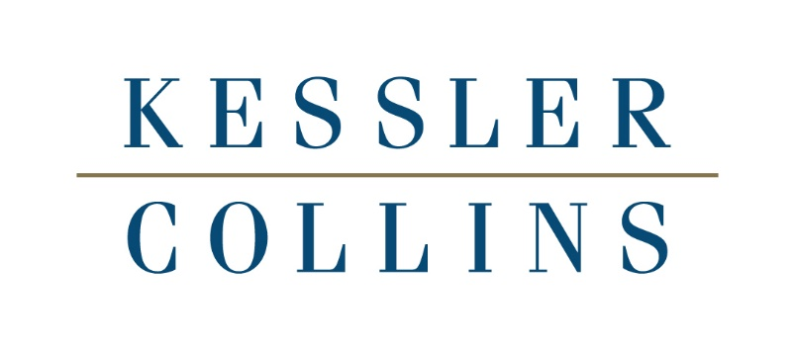

CONFERENCE HOST:
Kessler Collins
500 N. Akard Street, Suite 3700
Dallas, Texas 75201
(214) 379-0722

MEETING LOCATION:
Adolphus Hotel
1321 Commerce Street
Dallas, TX 75202
(214) 742-8200

- Wednesday October 25, 2023 6:00 PM – 8:00 PM
Welcome Reception – Adolphus Hotel, John Neely Bryan (Registration Level) Dress Code – Business Casual

- Thursday October 26, 2023 12:00 PM – 5:00 PM
8:30 – 9:00 Executive Committee Only Continental Breakfast – Pat Morris Neff (Mezzanine Level)
9:00 – 11:00 Executive Committee Only Meeting – Pat Morris Neff (Mezzanine Level)
12:00 – 12:45 Lunch Buffet – John Neely Bryan (Registration Level)
11:30 – 5:00 Registration Desk Open Outside Sam Rayburn AB (Registration Level)
1:00 – 5:00 General Session – Sam Rayburn AB (Registration Level)
1:00 – 1:15 Opening Remarks
1:15 – 2:15 From the Courtroom to the Boardroom: Winning Big by Utilizing Emotional Intelligence Knowledge and Strategies
Aimee Schleizer, LCSW Candidate, Former CFO for Financial Technology companies
Nick Roide, Associate, Kessler Collins
2:15 – 2:45 New Member Introductions
2:45 – 3:00 Afternoon Break – Networking
3:00 – 4:00 What is New in Employment Law: Legal Update for Law Firms and Their Clients
Ali Hinkley, Associate and Charmaine Voorhees Becken, Shareholder, Kessler Collins
4:00 – 5:00 Panel Discussion: The Importance of Succession Planning at Every Level; How to Strategically Build Levels in your Firm
Joe Collins VP & Shareholder, Tony Barbieri, President, & Shareholder, Chandler Saul Senior Associate, Kessler Collins
5:00 Closing Remarks – Adjourn Day One

- Thursday Dinner October 26, 2023 6:00 – 9:00 PM
Cocktail Reception and Dinner – El Fenix (Business Casual/Smart Casual attire)
Gather in Lobby. Bus leaves Hotel at 5:15 PM.

- Friday October 27, 2023 8:00 AM – 5:00 PM
8:00 – 8:45 Breakfast Buffet – John Neely Bryan (Registration Level)
8:30 – 5:00 Registration Desk Open Outside Sam Rayburn AB (Registration Level)
9:00 – 5:00 General Session – Sam Rayburn AB (Registration Level)
9:00 – 9:45 LNA Member Self-Introductions
9:45 – 10:45 Leadership Panel Discussion: Issues Facing Law Firms Today and How to Create and Implement Targeted Solutions
Tony Barbieri, President & Shareholder, Kessler Collins; Brett Crane, Managing Partner, Pray Walker
Paul Sandars III, Managing Partner, Lum Drasco
& Positan, Heather Barbieri, Of Counsel, Kessler Collins
10:45 - 11:00 Morning Break – Networking
11:00 – 12:00 Care for the Whole Business: How Focus on and Knowledge of Your Client’s Industry and Business Will Benefit the Development of Your Legal Strategies

Chandler Saul, Senior Associate, Kessler Collins
Stephen Huschka, Shareholder, Kessler Collins
12:15 – 1:15 Lunch Buffet – John Neely Bryan (Registration Level)
After Lunch Return to Sam Rayburn AB (Registration Level)
1:30 – 2:30 What Every Civil Lawyer Needs to Know About Criminal Law
Heather Barbieri, Managing Partner, Barbieri Law Firm
2:30 – 3:30 Hey ChatGPT, What are the Legal Issues Surrounding AI in the Workplace?
Tony Barbieri, President and Shareholder, Kessler Collins; Zachary Lutz-Priefert, Shareholder, Gross Welch Marks Clare
3:30 – 3:45 Afternoon Break – Networking
3:45 – 4:45 LNA Business Meeting
Treasurer’s Report
Executive Committee
JV Committee Report
Membership Committee Report
Communications Committee Report
LNA Europe Report
Website/Social Media Report
4:45 – 5:00 Closing Remarks – Adjourn Day Two

- Friday Dinner October 27, 2023 6:00 – 9:00 PM
Cocktail Reception and Dinner – The Capital Grille (Business Casual/Smart Casual Attire)
Gather in Lobby. Bus leaves Hotel at 5:30 PM

