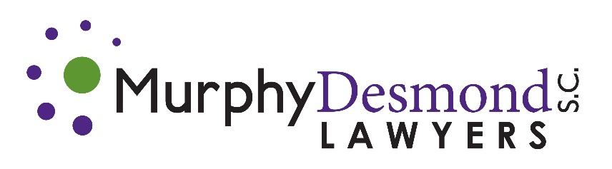

CONFERENCE HOST:
Murphy Desmond S.C.
33 East Main Street, Suite 500
Madison, Wisconsin 53703
(608) 257-7181

MEETING LOCATION:
Park Hotel
22 South Carroll Street
Madison, Wisconsin 53703
(608) 285-8000

- Wednesday October 12, 2022 6:00 PM – 7:30 PM
Welcome Reception – Murphy Desmond S.C. (Business Casual)
Meet in Hotel Lobby at 5:45 PM for 2-block walk to the venue

- Thursday October 13, 2022 10:00 AM – 5:00 PM
8:30 - 9:30 Executive Committee Continental Breakfast – University (Second Floor)
9:30 – 11:45 Executive Committee Meeting – Capitol East (Second Floor)
12:00 – 12:45 Lunch Buffet – University (Second Floor)
11:30 – 5:00 Registration Desk Open (Mezzanine)
1:00 – 5:00 General Session – Madison (Second Floor)
1:00 – 1:15 Opening Remarks
1:15 – 1:45 New Member Introductions
1:45 – 2:45 A Clean Lakes Alliance Success Story
J. James Tye III and Paul Dearlove, Clean Lakes Alliance and Matthew Frank, Esq., Murphy Desmond S.C.
2:45 – 3:00 Afternoon Break – Networking
3:00 – 4:00 Employment-Based Immigration:
Principles and Practice
Maryam Ghayyad, Esq., Murphy Desmond S.C.
4:00 – 5:00 Panel Discussion: Post-Covid Return to Work Matthew Fleming, Esq. and Ginger Zimmerman, Esq., Murphy Desmond S.C., Anthony Barbieri, Esq., Kessler Collins, Neal Weinstein, Esq., Ingram Yuzek Gainen Carroll Bertolotti LLP
5:00 Closing Remarks – Adjourn Day One

- Thursday Dinner October 13, 2022 6:00 – 9:00 PM
Cocktail Reception and Dinner – Buck & Honey’s - Monona (Business Casual/Smart Casual attire)
Gather in Lobby at 5:15 PM. Bus leaves Hotel at 5:30 PM.

- Friday October 14, 2022 8:00 AM – 5:00 PM
8:00 – 8:45 Breakfast Buffet – University (Second Floor)
8:45 – 5:00 Registration Desk Open (Mezzanine)
9:00 – 5:00 General Session – Madison (Second Floor)
9:00 – 9:45 LNA Member Self-Introductions
9:45 – 10:45 “Show Me the Money” – Sports Agency in Private Practice
Tim Valentyn, Esq., Former longtime partner, and President of Murphy Desmond S.C.
10:45 - 11:00 Morning Break – Networking
11:00 – 12:00 Data Do’s and Data Do Not Do’s
Mark Maciolek, Esq., Murphy Desmond S.C.
12:15 – 1:15 Lunch Buffet – University
1:30 – 2:30 Wind Energy: Opportunities and Challenges for a Sustainable Energy Future
James Tinjum, Ph.D., University of Wisconsin-Madison
2:30 – 3:30 Best Practices Panel Discussion: Law Firm Marketing in 2022 – What Works and What Doesn’t
Murphy Desmond S.C. Shareholder, Matthew Fleming, Esq., Kessler Collins Associates, Anne-Alise (Ali) Hinckley, Esq. and Chandler Saul, Esq., and Murphy Desmond S.C. Marketing Director, Amy Gores.
3:30 – 3:45 Afternoon Break – Networking
3:45 – 4:45 LNA Business Meeting
Treasurer’s Report
Executive Committee Composition
JV Committee Report
Membership Committee Report
Communications Committee Report
LNA Europe Report
Website/Social Media Report
Technical Training Videos
4:45 – 5:00 Closing Remarks – Adjourn Day Two

- Friday Dinner October 14, 2022 6:00 – 9:00 PM
Cocktail Reception and Dinner at Rare Steakhouse (Business Casual/Smart Casual)
Meet in Hotel Lobby at 5:45 PM for 2-block walk to the venue

